
Lab 10
Topic | Types of Functions in SQL
Objective | - Understand the concept of SQL Functions.  - Learn different types of SQL functions.  - Use functions to manipulate and analyze data.  - Apply functions in queries using MySQL Workbench.
Learning Outcomes of This Lab:
After completing this lab, students will be able to:
- Understand what SQL functions are.
- Differentiate between types of SQL functions.
- Use aggregate functions for data analysis.
- Apply scalar (single-row) functions.
- Use string, and numeric functions.
- Execute function-based queries in MySQL Workbench.

Introduction to SQL Functions

What are SQL Functions?
SQL Functions are predefined operations used to perform calculations on data and return a result.
Functions help in:
- Data analysis
- Data transformation
- Formatting output

Types of Functions in SQL:
SQL functions are mainly divided into two categories:
Type | Description
Built-In Functions | Already build and you can use them
User Defined Functions | You can define your own functions

Types of Built-in Functions in SQL:
Built-In SQL functions are mainly divided into two categories:
Type | Description
Aggregate Functions | Operate on multiple rows and return a single value
Scalar Functions | Operate on a single value and return a single value

- Aggregate Functions:
Aggregate functions perform calculations on a set of values.
Common Aggregate Functions:
Function | Purpose
COUNT () | Count number of rows
COUNT DISTINCT () | Find out unique count
SUM () | Calculate total
AVG () | Calculate average
MAX () | Find maximum value
MIN () | Find minimum value
STD () | Find the standard deviation

Syntax:
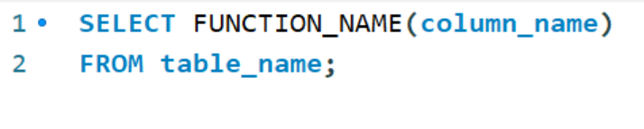
Examples:
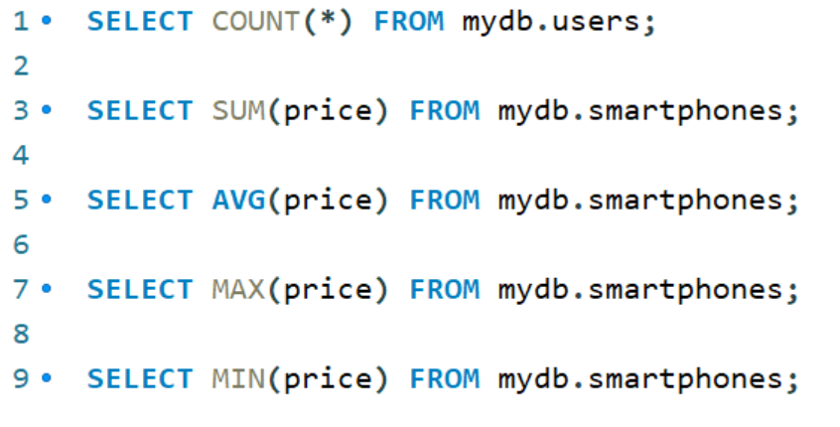

- Scalar (Single Row) Functions:
Scalar functions work on each row individually. They are further divided into:
A. String Functions
Used to manipulate text data.
Common String Functions:
Function | Purpose
UPPER () | Convert to uppercase
LOWER () | Convert to lowercase
LENGTH () | Find length of string
CONCAT () | Join strings

Examples:
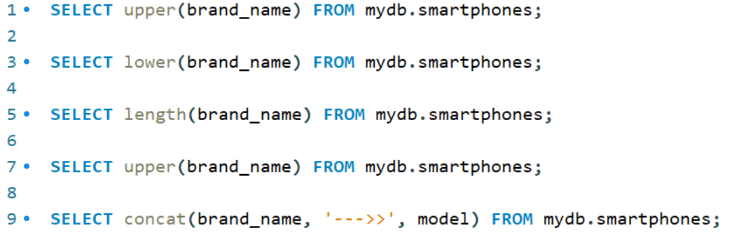

B. Numeric Functions
Used for mathematical operations.
Common Numeric Functions:
Function | Purpose
ROUND () | Round value
CEIL () | Round up
FLOOR () | Round down
ABS () | Absolute value

Examples:
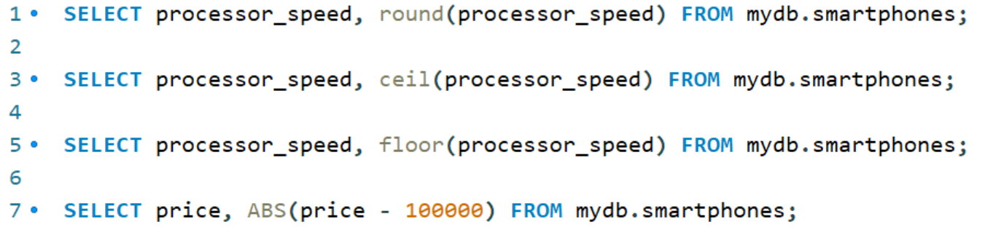

Lab Tasks

Tool: Use MySQL Workbench.

Task 01
Find the maximum and minimum price from smartphones table.

Solution:
FOR MAX

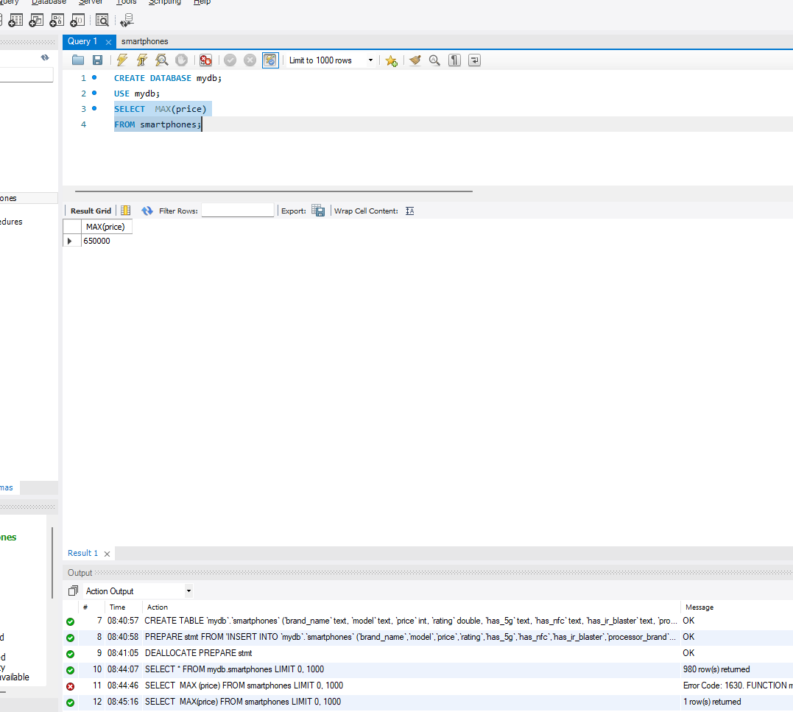

FOR MIN
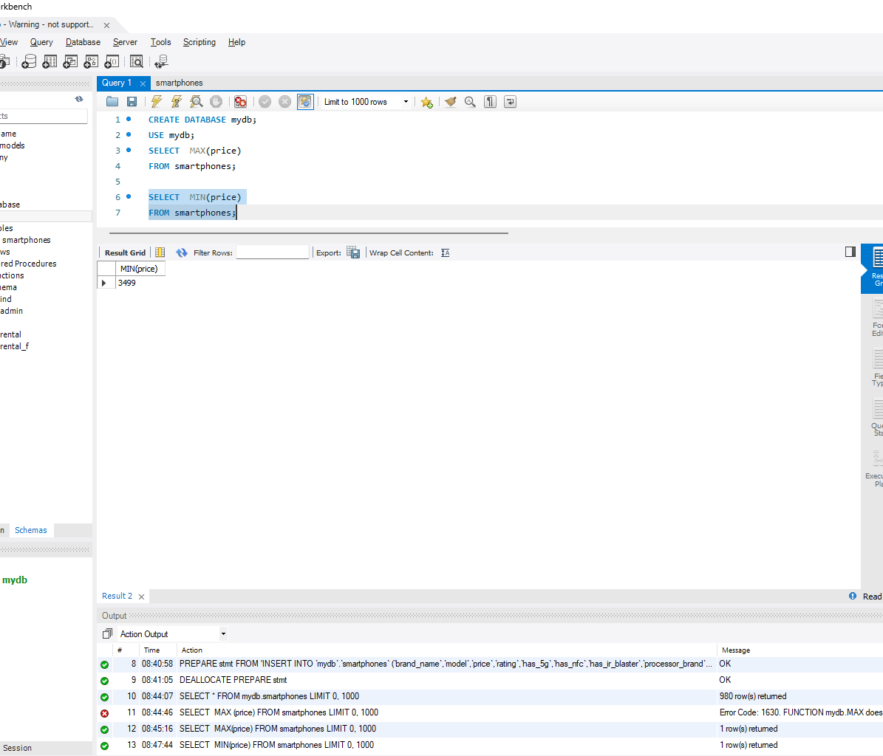

Task 02
Find the maximum and minimum RAM Capacity from smartphones table.

Solution:
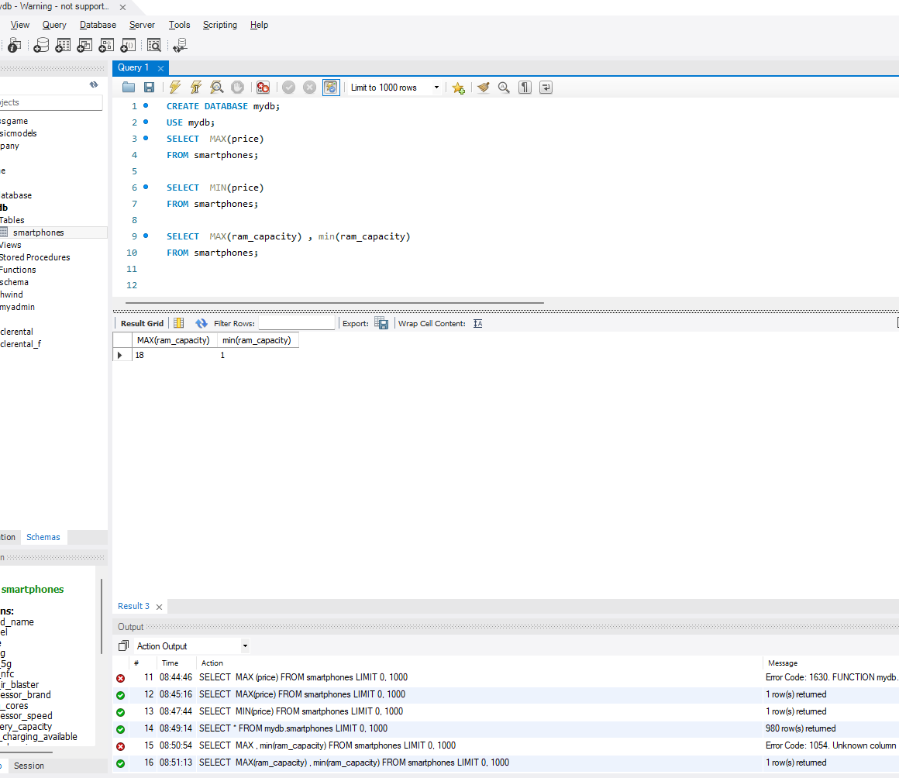

Task 03
Find the price of the costliest Samsung phone.

Solution:
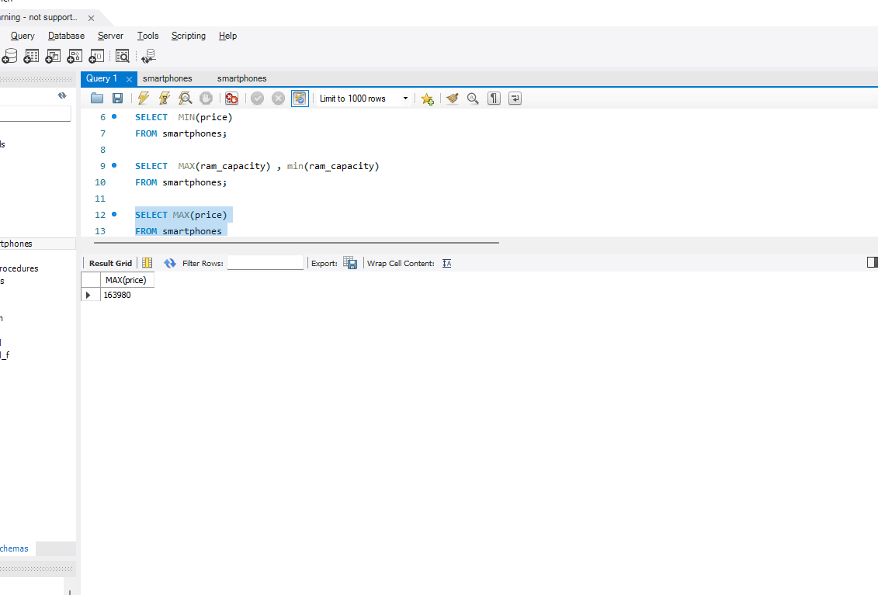

Task 04
Find the AVG rating of Apple phones.

Solution:
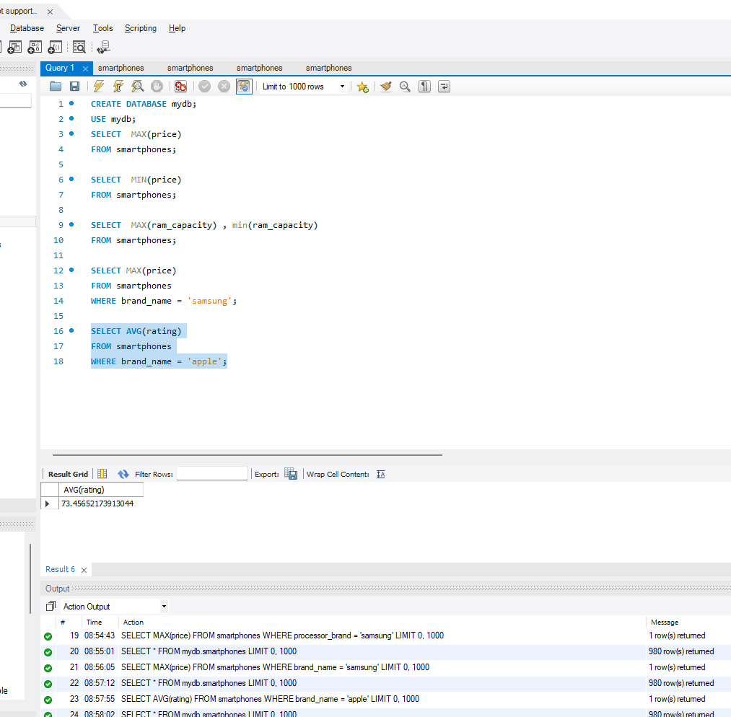

Task 05
Find the No. of Samsung mobile phones.

Solution:
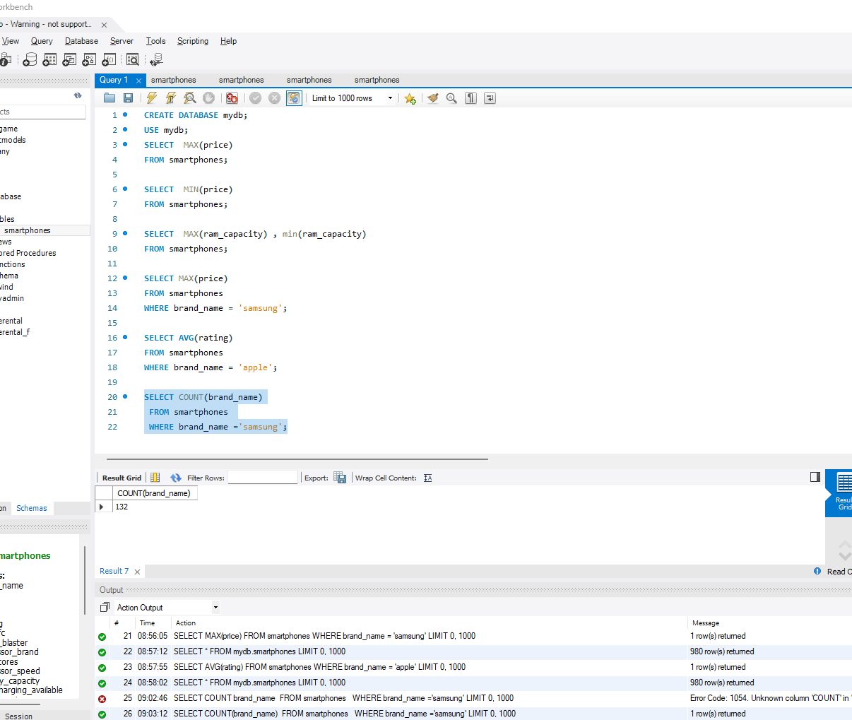

Task 06
Find the number of Brands available in table smartphones.

Solution:
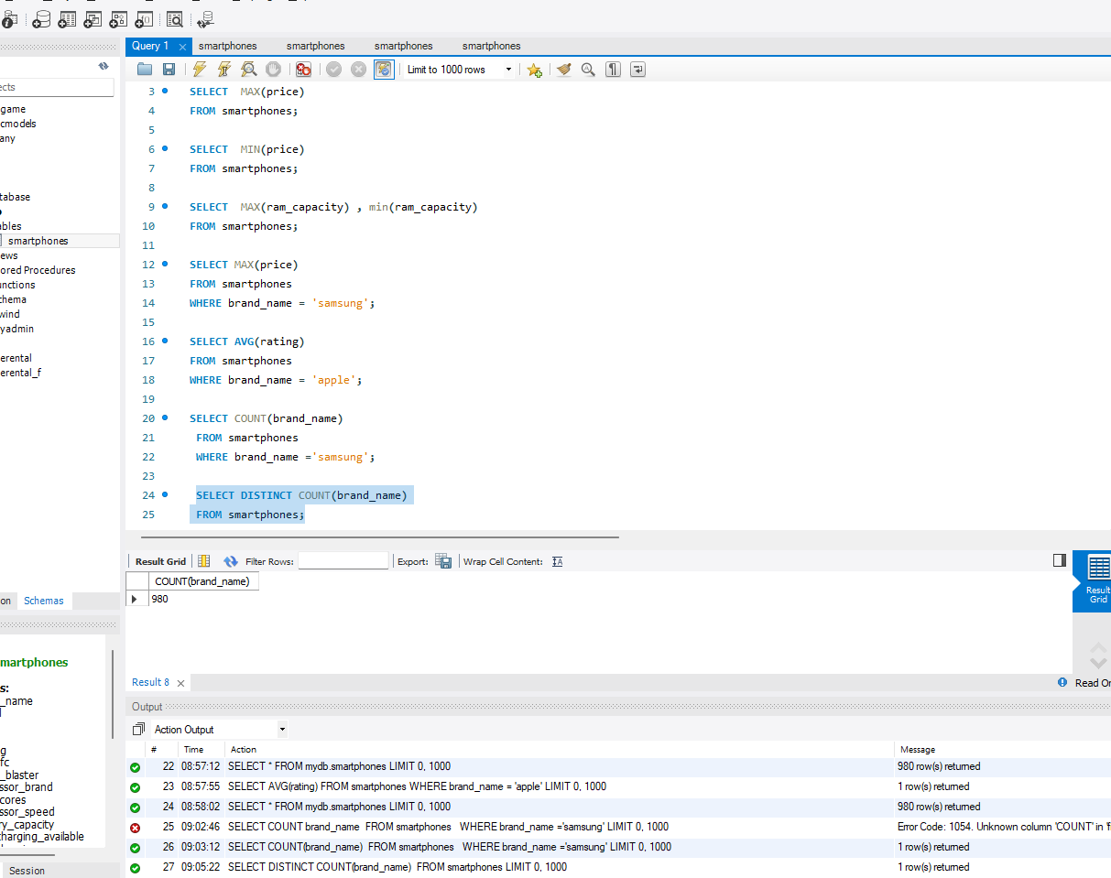

Task 07
Find the standard deviation of screen sizes from table smartphones.

Solution:
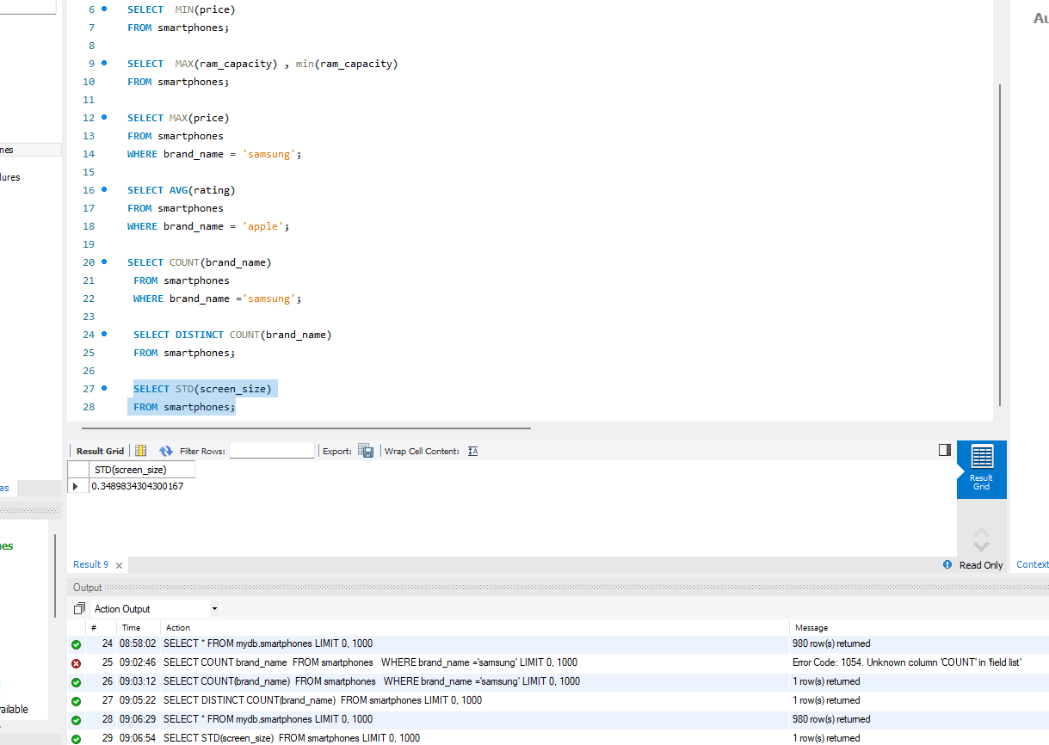

FINAL CODE
CREATE DATABASE mydb;
USE mydb;
SELECT MAX(price)
FROM smartphones;

SELECT MIN(price)
FROM smartphones;

SELECT MAX(ram_capacity) , min(ram_capacity)
FROM smartphones;

SELECT MAX(price)
FROM smartphones
WHERE brand_name = 'samsung';

SELECT AVG(rating)
FROM smartphones
WHERE brand_name = 'apple';

SELECT COUNT(brand_name)
FROM smartphones
WHERE brand_name ='samsung';

SELECT DISTINCT COUNT(brand_name)
FROM smartphones;

SELECT STD(screen_size)
FROM smartphones;
***********

